**Report on Project Hope**

**Executive Summary:**

In an increasingly interconnected world, mental health and emotional well-being are paramount. "Project Hope" emerges as a beacon of solace, a global platform designed to unite individuals from every corner of the globe who grapple with mental instability, depression, relationship issues, and a myriad of other challenges. Our mission is clear: to establish a secure and judgment-free space where individuals can share their burdens, find support, and embark on a journey toward healing.

**The Need:**

The prevalence of mental health issues is on the rise, affecting millions worldwide. Depression, anxiety, and relationship challenges are often isolating experiences, exacerbated by societal stigmas and misconceptions. Recognizing the urgency of addressing these issues, Project Hope seeks to create a bridge of understanding and empathy, fostering a global community that stands united against the shadows of mental health struggles.

**The Platform:**

Project Hope is more than just a platform; it is a lifeline for those navigating the complexities of their mental and emotional well-being. Through a user-friendly interface, individuals can connect, share their stories, and provide support to one another. The platform incorporates various mediums such as forums, live chats, and virtual support groups, ensuring a diverse range of channels through which users can find solidarity and encouragement.

**Our Approach:**

What sets Project Hope apart is its commitment to cultivating a judgment-free environment. We understand that everyone's journey is unique, and no two struggles are identical. By fostering open communication and promoting active listening, Project Hope empowers individuals to share their vulnerabilities without fear of judgment, fostering a sense of community that transcends borders.

**The Impact:**

Project Hope aims to create a ripple effect of positive change. By facilitating connections and breaking down the barriers of isolation, we envision a world where individuals feel understood, supported, and empowered to seek professional help when needed. The impact of this global community will extend beyond the virtual realm, fostering resilience, empathy, and understanding in the face of mental health challenges.

**2. Key Features**

**[Feature 1]: Accessible Support, Free of Charge:**

In a landscape where support often comes at a cost, Hope stands apart by offering its platform entirely free of charge. We believe that everyone deserves access to a supportive community without financial barriers. Hope is committed to making a positive impact on the lives of those in need, irrespective of their financial circumstances.

**[Feature 2]: Intelligent Chatbot Assistance:**

Hope goes beyond traditional support avenues with the integration of an intelligent chatbot. This personalized assistant is designed to engage with users, providing immediate support tailored to their specific needs. Whether someone is navigating through a bout of depression or seeking guidance on relationship issues, our chatbot is a companion that listens, understands, and offers empathetic responses.

**[Feature 3]: Safe and Inclusive Community Spaces:**

Hope prioritizes the creation of safe and inclusive community spaces. Users can engage in forums, live chats, and virtual support groups, fostering connections with like-minded individuals who understand their struggles. Our commitment to a judgment-free environment ensures that users can express themselves authentically, promoting a sense of belonging and camaraderie.

**[Feature 4]: Resourceful Content Hub:**

Hope serves as not only a platform for sharing but also as a resourceful content hub. Users can access articles, expert advice, and self-help materials to empower themselves on their journey to emotional well-being. The platform strives to be a comprehensive source of information, offering insights and strategies to navigate the complexities of mental health.

**[Feature 5]: Global Reach, Local Impact:**

Hope transcends geographical boundaries, connecting individuals worldwide. The platform acknowledges the universality of mental health struggles while also recognizing the unique cultural nuances that shape personal experiences. Through this global reach, Hope aims to create a diverse, yet interconnected, tapestry of support.

**3. User Experience:**

Certainly, incorporating visuals and providing a link to your webpage for users to experience firsthand is an excellent approach to showcase the user experience. Below is a revised section on User Experience:

At Hope, we understand that the true measure of our impact lies in the experience of our users. We take pride in delivering an intuitive and empathetic user experience that prioritizes accessibility and connection.

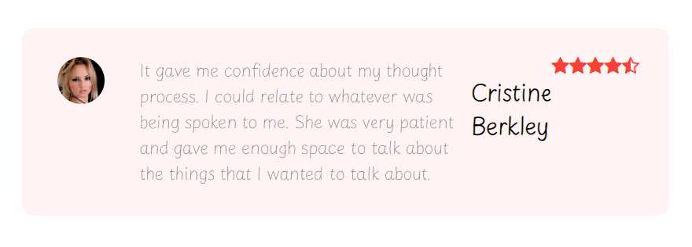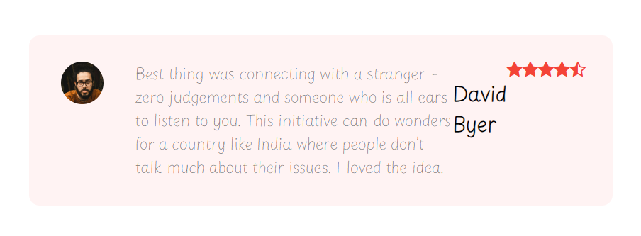

Our platform has been crafted with a keen focus on simplicity and ease of navigation, ensuring that users can seamlessly navigate through various features without unnecessary complications. The visual aesthetics are thoughtfully designed to provide a calming and welcoming environment, contributing to the overall positive experience.

**User Ratings and Testimonials:**

To further substantiate the quality of our user experience, we encourage you to view the user ratings and testimonials on our webpage. Real stories from individuals who have found solace and support on Hope speak volumes about the impact of our platform.

Check out what our users have to say about their experience on Hope [here](insert_testimonials_link_here).

At Hope, we believe that the best way to understand the transformative power of our platform is to experience it firsthand. Click the links above to immerse yourself in the Hope community and witness how we are redefining the user experience for those seeking connection, understanding, and hope.

**Community and Social Engagement:**

Hope is not just a platform; it's a global community that transcends borders, inviting individuals from every corner of the world to join hands in a journey of empathy, understanding, and support. Our mission is rooted in providing a judgment-free space where people grappling with mental health challenges, depression, relationship issues, and more can find solace through connection.

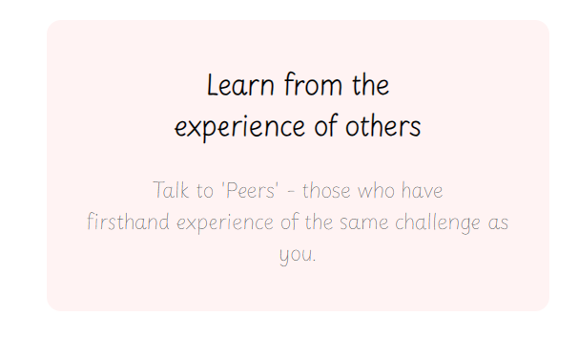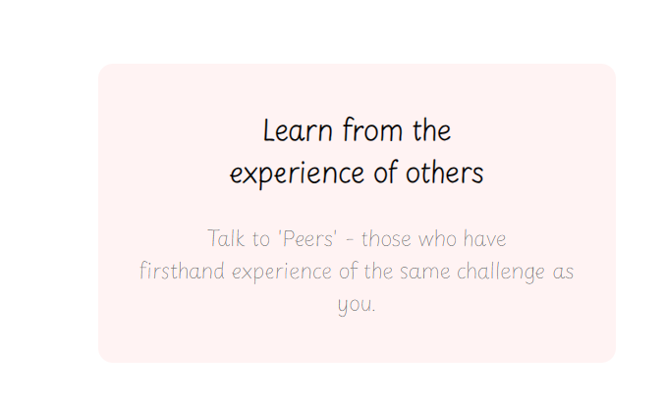

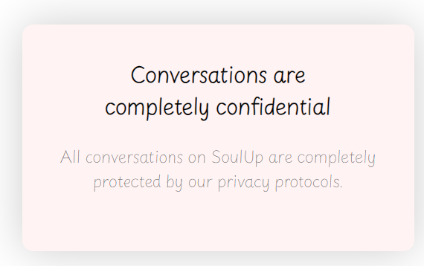

**User Interaction:**

At the heart of Hope's ethos is the power of user interaction. Our platform is designed to encourage meaningful engagement, fostering a community where individuals actively listen, share, and uplift one another. Through forums, live chats, and virtual support groups, users have the opportunity to connect on a personal level, creating a tapestry of shared experiences that binds us together in our collective pursuit of well-being.

Join the conversation, lend an ear, or share your story - your voice matters in the Hope community.

**Social Media Integration:**

Hope recognizes the significance of connectivity in the digital age. To amplify our mission and reach individuals far and wide, we seamlessly integrate with various social media platforms. This integration not only facilitates broader community outreach but also encourages users to bring the spirit of Hope to their existing social networks. By sharing stories, insights, and resources, we create a ripple effect of understanding and support that extends beyond the confines of our platform.

*Connect with us on [insert_social_media_links_here] and be a beacon of hope within your own digital community.*

At Hope, we believe that every interaction, whether within our platform or across social media, contributes to the collective strength of our community. Through user engagement and social integration, we are not merely building a platform; we are nurturing a global movement where compassion knows no boundaries, and understanding spans the entire world. Together, let's forge connections that heal and empower.

**4.Content:**

**1. Introduction:**

The HTML code provided is the structural foundation for the "HOPE" website. The website is designed as a global platform aiming to bring people together from around the world, offering support and understanding for those dealing with mental health issues, depression, relationship challenges, and more. The code establishes the structure of the web pages, incorporates styling through CSS, and integrates essential functionalities.

2. Key Features:

**Responsive Design:** The code includes a meta tag for viewport settings, ensuring the website's responsiveness on various devices.

**External Style Sheet:** The code links to an external stylesheet ("style.css") to maintain separation of concerns and streamline the styling process.

**Font Integration:** Different fonts are incorporated into the website using Google Fonts and Font Awesome, adding visual appeal and enhancing the user experience.

**Navigation:** The navigation bar is well-organized with links to different sections of the website, providing easy access for users.

**Interactive Menu:** The code includes JavaScript functions to toggle the display of the navigation menu, enhancing user interactivity.

3**. User Experience:**

- The webpage features a visually appealing design with a prominent logo ("hopelogo.png") and engaging text.

- Clear and concise headings and paragraphs provide information about the platform's mission and offerings.

**4.** **Recommendations:**

Ensure that the empty href attributes in the navigation links are populated with the correct URLs.

Consider adding alt attributes to images for accessibility.

Continuously update and expand content to keep users engaged and informed.

Regularly test the website's responsiveness across various devices and browsers to ensure a seamless user experience.

**Future Developments:**

As we stride into the future, Hope is poised to elevate its user experience to new heights. Anticipating the evolving needs of our community, we are thrilled to announce the upcoming launch of the Hope Application. This revolutionary step signifies our commitment to creating a more accessible and immersive platform for mental health support.

Key Features in the Upcoming Hope Application:

**1. 1-on-1 Video Chat:**

Unveiling a personalized and private space, our 1-on-1 video chat feature ensures that individuals can connect with empathetic listeners and mental health supporters in a direct and confidential setting. This feature empowers users to forge deeper connections and receive tailored support tailored to their unique journey.

**2. Group Chat Through Video Call:**

Recognizing the strength in community, we are introducing group chat functionality through video calls. Users will have the opportunity to engage in meaningful conversations with multiple peers simultaneously, fostering a sense of camaraderie and shared understanding. This collective approach to support encourages diverse perspectives and creates a vibrant tapestry of shared experiences.

**Our Commitment:**

At Hope, our long-term vision extends beyond the mere provision of a platform. We are dedicated to creating a dynamic and evolving ecosystem that adapts to the changing landscape of mental health support. By introducing these innovative features on our application, we reaffirm our commitment to fostering a global community where empathy knows no bounds, and individuals can find solace, understanding, and hope.

As we embark on this exciting journey, our focus remains on providing a safe, judgment-free space that empowers users to navigate the complexities of their mental health with resilience and support. The Hope Application is not just a technological advancement; it is a testament to our unwavering dedication to the well-being of our community.

Join us as we step into the future of mental health support, where connection transcends physical boundaries, and the power of empathy transforms lives. Together, let's continue building a world where everyone, irrespective of their struggles, can find strength, encouragement, and most importantly, hope.

**Conclusion: Building Bridges to Hope**

In conclusion, Project Hope stands as a testament to the power of compassion, understanding, and connection in the realm of mental health and emotional well-being. In our interconnected world, where millions grapple with the shadows of mental instability, depression, and relationship challenges, Project Hope emerges as a beacon of solace.

The urgent need to address the rising prevalence of mental health issues propelled the creation of Project Hope. It goes beyond being a mere platform; it is a lifeline, a bridge of understanding and empathy that unites individuals from diverse corners of the globe. The commitment to establishing a secure and judgment-free space reflects our mission to empower individuals to share their burdens and embark on a transformative journey toward healing.

Project Hope's impact is envisioned as a ripple effect of positive change, breaking down barriers of isolation and fostering a global community that understands, supports, and empowers. The platform's key features, from accessible support free of charge to the intelligent chatbot assistance, create a diverse tapestry of support channels. The emphasis on safe and inclusive community spaces and a resourceful content hub adds depth to the user experience, promoting a sense of belonging and camaraderie.

User experience lies at the heart of Project Hope, with a focus on simplicity, ease of navigation, and a visually appealing design. Real stories from users, shared through testimonials and ratings, serve as a testament to the platform's transformative power. Project Hope is not just a platform but a global community that transcends borders, inviting individuals to join hands in a collective pursuit of well-being.

The integration of social media amplifies the platform's reach, encouraging users to share stories, insights, and resources beyond the confines of Project Hope. The commitment to user interaction fosters a tapestry of shared experiences, binding the community together.

As we stride into the future, the upcoming Hope Application signifies our commitment to elevating the user experience. Features like 1-on-1 video chat and group chat through video call will provide more personalized and collective avenues of support, adapting to the evolving needs of our community.

Project Hope's commitment remains unwavering — not just a technological advancement, but a dedication to the well-being of our global community. Together, let us step into the future of mental health support, where connection knows no bounds, and the power of empathy transforms lives. Join us in building a world where everyone, irrespective of their struggles, can find strength, encouragement, and, most importantly, hope.